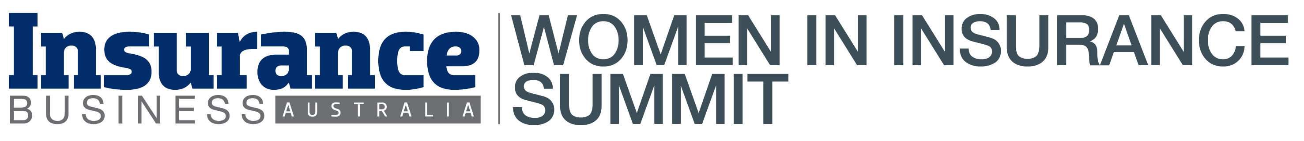

Thank you for participating at the Women in Insurance Summit Australia on the 21st of August 2024 at the Fullerton Hotel Sydney organised by Key Media.

*Topics covered:*

* OPENING KEYNOTE: Creating the conditions for high performance
* PANEL: Empowering women in insurance – achieving leadership success
* How the gender pay gap can inspire contemporary leadership and contribute to gender equal experiences
* FIRESIDE CHAT: The economic outlook and its impact on insurance
* Finding a mentor is a key driver to a successful career in insurance
* Mindfulness break: Practising mindfulness to re-energise and re-focus
* PANEL: Embracing generative artificial intelligence in insurance
* WORKSHOP: How to remain resilient in the face of adversity
* PANEL: Addressing the generational divide – creating inclusive cultures

[INSERT NAME HERE]

For any queries please contact Janina Sarmiento at [janina.sarmiento@keymedia.com](mailto:janina.sarmiento@keymedia.com)

